**Web Programming Lab**

**1.** Design a HTML5 webpage for **SIT HALCYON** summer fest. The document must contain the following:

-Fest Heading (center of the page with color font)

-Two paragraphs which describes about HALCYON

-Create unordered list of 5 Halcyon events and ordered list of 3 cash prizes

-Add a marquee “SIT Summer Fest 2025

-Insert a suitable background image and display the following output to register for Dance event

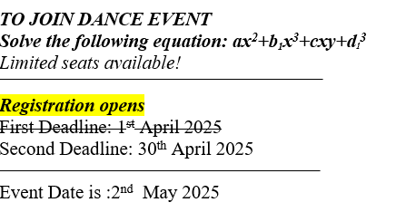

**2. Create following tables using HTML5. Properly align cells, give suitable cell padding and cell spacing, and apply background color, bold and emphasis necessary**

1. Insert SIT college logo, followed by college name & department title
2. Add two paragraphs about the college and department

(for example)



1. Create following table using HTML5

|  |  |  |  |
| --- | --- | --- | --- |
| **Department** | **Semester** | **Sl. No & Name** | |
| ***Sem3*** | 1 | Adam |
| 2 | Alice |
| ***Sem4*** | 3 | Bob |
| 4 | Cavin |

1. Design the time table of your class

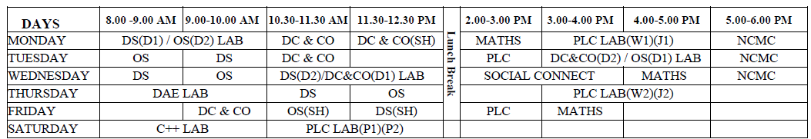

**3. Use HTML5 for performing following tasks: Insert suitable title, background colour, text colour for each div.**

1. Draw a square using HTML5 SVG , fill the square with green color and make 6px brown stroke width
2. Draw a rectangle using HTML5 SVG , fill the rectangle with blue color and make 8px red stroke width
3. Draw a ellipse using HTML5 SVG , fill the ellipse with orange color and make 3px bluestroke width
4. Draw a circle using HTML5 SVG , fill the circle with yellow color and make 4px greenstroke width
5. Draw a pentagon using HTML5 SVG , fill the pentagon with black color and make 4px greenstroke width
6. Write the following mathematical expression by using HTML5 MathML. d=x2-y2  and Quadratic equation
7. Redirecting current page to another page after 5 seconds using HTML5 meta tag